Lesson 4 – Simple Selection
Making a Decision: the evaluation of an expression that yields (gives) either a TRUE (yes) or a FALSE (no) as its “result”.
relational expression
Relational Expression: Expression that compares two things to each other, giving either a TRUE (yes) or a FALSE (no) as an answer.

It uses a relational operator (set of 6):
Pseudocode Java
< >= < >=
> <= > <=
= NOT= == !=

Each is the opposite of its “partner”.

Always compare like with like.

Be careful when comparing for direct equality with decimal numbers.

Comparing Strings in Java………….......not so simple at all!!!!! (tearing-out-my-hair emoji)
One-way branching decision structure (Voting)

Flowchart
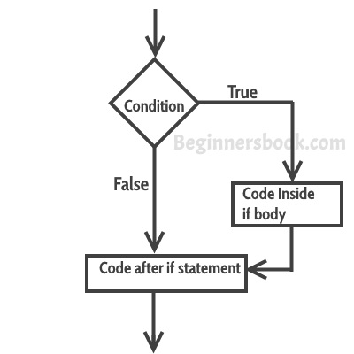

Pseudocode | Java

Two-way branching decision structure (divisor is 0)

Flowchart
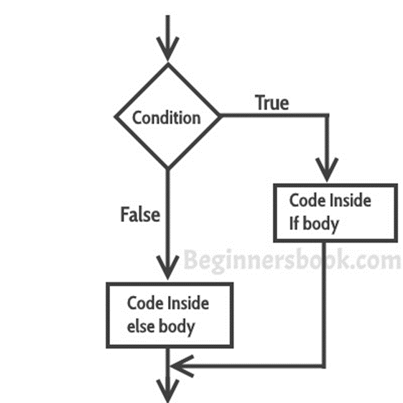

Pseudocode | Java

To do:
Write a small JAVA program that reads in two integers from the user (num1 and num2) and then calculates and displays their sum, diff, prod and quot.
If the quotient cannot be calculated (denominator is equal to zero), display an appropriate error message instead.

COMPARING STRINGS
Using the equals( ) method:

e.g. if ( surname.equals(“Wessels”) )

returns True if the contents equal “Wessels”
returns False if contents do not equal “Wessels”

The parameter can be a String variable instead of a String literal like “Wessels”

Pseudocode | JAVA
IF (surname = “Swart”)  THEN DISPLAY “They are identical”  ELSE DISPLY “They are NOT identical”  ENDIF  IF (surname1 = surname2)  etc. | if (surname.equals(“Swart”))  System.out.println(“They are identical”);  else  System.out.println(“They are NOT identical”);  if (surname1.equals(surname2))  etc.

Using the compareTo( ) method:

e.g. surname.compareTo(“Wessels”)

returns 0 if contents equals “Wessels”

returns negative number if contents are “less than” the literal “Wessels”

returns positive number if contents are “more than” the literal “Wessels”

Pseudocode | JAVA
IF (surname = “Swart”)  THEN DISPLAY “They are identical”  ELSE DISPLY “They are NOT identical”  ENDIF  IF (surname < “Swart”)  THEN DISPLAY “Comes BEFORE Swart”  ELSE DISPLY “Is, or comes AFTER,  Swart”  ENDIF  IF (surname > “Swart”)  THEN DISPLAY “Comes AFTER Swart”  ELSE DISPLY “Is, or comes BEFORE,  Swart”  ENDIF | if (surname.compareTo(“Swart”) == 0)  System.out.println(“They are identical”);  else  System.out.println(“They are NOT identical”);  if (surname.compareTo(“Swart”) < 0)  System.out.println(“Comes BEFORE Swart”);  else  System.out.println(“Is, or comes AFTER,  Swart”);  if (surname.compareTo(“Swart”) > 0)  System.out.println(“Comes AFTER Swart”);  else  System.out.println(“Is, or comes BEFORE,  Swart”);

Comparing String values (“lexicographical” comparison)

- Character by character
- Stops comparing at first difference
- Bases whole “answer” on the difference between these two characters (doesn’t compare further).

(space).............0, 1....... 9............A, B, C...........Z............a, b, c.............z.............

smallest...........................................................................................................biggest

